1.Look at the pictures and write
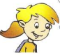
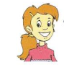
Lisa
Amy
John
Tony
Peter

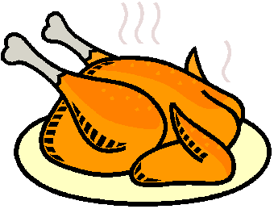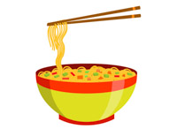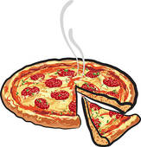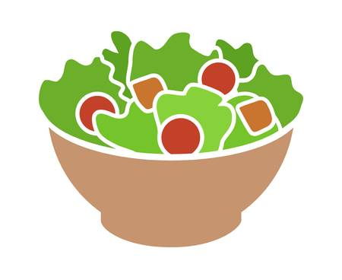
a. Peter has noodles.
b. Tony________________________________________.
c. John ________________________________________.
d. Amy ________________________________________.
e. Lisa ________________________________________.
2.Complete with have or has
a. I ________ chicken. b. She _________ an apple. 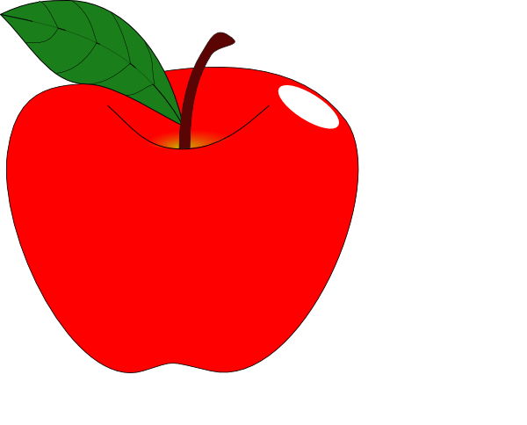
c. She _________ a pizza. d. He __________ a milkshake.
e.I ________ a sandwich. 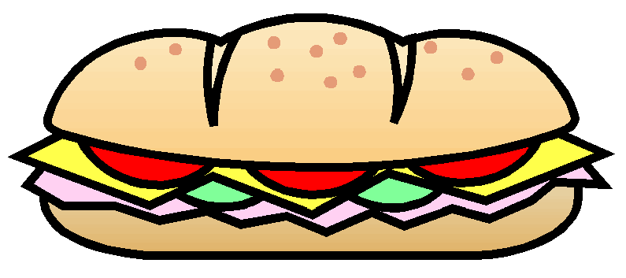 f. They ____________ grapes. 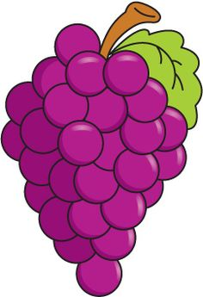
g. Lisa _______ salad . h. Lisa ________ a banana. 

3 .Reorder the words to make the correct sentences.
a. Does /have /she / a /banana ?/ __________________________________.?
b. have /Do /apple ? /you /an /_____________________________________?
c. She / has / fries./ __________________________________.
d. chicken./Mary / has / _____________________________.
e. /an /orange./ He /has /__________________________________.
f. have /We/ a /pizza./ _________________________________.
g. They /have / sweets./ _______________________________.
h. Does/ have/ she / salad ?/ __________________________________?
i. Lily / an /orange./ has / ______________________________.
j. they/ Do/ have/ biscuits?/ ____________________________________?
4.Complete the sentences.
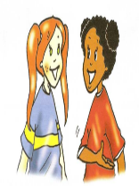 | 1.They have some milk but they don’t have any yogurt.  2.They _________a banana but they __________an orange.  3.They _____________ a hamburger but they________ noodles.  4.They _________ any juice but they ________some fries. | 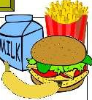
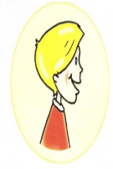 | 1.He has some juice but he doesn’t have any chips .  2.He __________a sandwich but he __________ chicken..  3.He _________any milk but he ___________some yogurt.  4.He _________a banana but he _________an orange. | 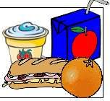
5. Fill in the blanks.
a. Do you have an apple ? Yes , I ___________________.
b. Does she have a banana ? No , _________________.
c. Do they have fries ? Yes , _____________________.
d. What do you have ? I ______________ a pizza.
e. What does she have ? She ____________ chicken.
f. Does she have a sandwich ? Yes , she ___________.
g. Does he have grapes ? Yes , _________ does.
h. What does he have ? He ______________ an apple.
i. ___________ she have chicken ? Yes , she does.
j. What _________ she have ? She has salad.
k. Does Lily have a pizza ? ____________ , she does.
l. Does Peter have noodles ? No , he __________.

